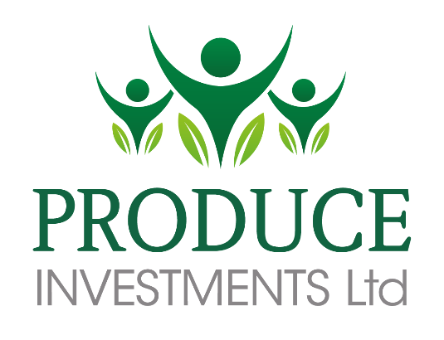

# Produce Investments

# Corporate Social Responsibility Policy

**We care about what we do...**

**Contents**

Produce Investments 1

Corporate Social Responsibility Policy 1

Contents 2

Chief Executive Statement 3

Understanding Produce Investments 4

Our Vision 4

Our Values: 5

Produce Investments and CSR 6

Our CSR Vision 6

Our Environment 7

Greenvale AP 7

Greenvale AP operational sites: 8

Our Growers 9

Responsible Sourcing and Ethical Trading 11

Ethical Policy 11

Supporting British Farmers and Local Produce 12

Working in partnership with our growers 12

Our People 13

Health & Safety 13

Learning and Development 14

14

14

Engagement 15

Benefits 15

Produce Investments in the local community 16

Supporting Education and the Local Community 16

Supporting Charities 17

# Chief Executive Statement

At Produce Investments, we take corporate social responsibility (CSR) seriously and are proud of the way we demonstrate our commitment to the environment, our people and the community.

We are also extremely proud of the way in which we operate as a business. As a leading player in the fresh potato and daffodil sectors, Produce Investments believes it has a responsibility to help shape the way in which our group companies operate, continually challenging convention and looking for technological advances that can help our companies and respective sectors become more efficient, thus reducing our collective environmental impact.

Please read onto find out more about our approach to CSR…

Angus Armstrong

Chief Executive

# Understanding Produce Investments

Produce Investments Ltd, is a leading operator in the fresh potato and daffodil sectors.

We have operations throughout the UK in growing and packing and serve a number of market sectors including retail, food service, wholesale and trading.

Outside of the UK our ethylene storage and ripening business, Restrain continues to grow.

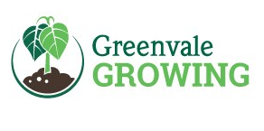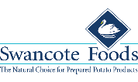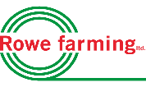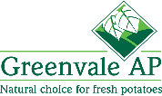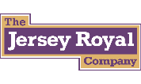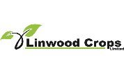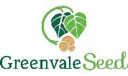

# Our Vision

To improve our position as a leading supplier in the UK fresh potato and daffodil market, retaining our unique customer diversity and improving the efficiency of everything we do by 2020.

This will be achieved by:

* acquiring quality businesses that offer synergies and product and / or customer diversification
* funding the organic growth strategies of the groups subsidiary companies

# Our Values:

**Business Ethics**

We’ll always conduct business with integrity and respect to human rights. We’ll promote:

* Safety and fair dealing
* Respect towards the consumer
* Anti-bribery and anti-corruption practices

**Protecting the environment**

We recognise the need to protect the natural environment. As a group our businesses rely heavily on the environment and its natural resources, we take pride and responsibility in our businesses mitigate their impact.

**Protecting People**

We’ll ensure that we:

* Don’t risk the health and safety of our employees and community
* Support diversity and inclusion
* Comply with legislation set out by the Modern Slavery Act

# Produce Investments and CSR

In order for a CSR Policy to be successful we believe it must be aligned with our core values and be incorporated into the way we operate as a business day-to-day. By considering the wider social and environmental impacts of our actions we can make better decisions to ensure the long-term sustainability of Produce Investments.

As the parent company of one of the largest fresh potato suppliers we embrace our responsibility to the environment, our employees and the local communities in which we operate. We are determined to continue improving and exceeding expectations. We see CSR as an integral part of that as we move forward.

# Our CSR Vision

Continue to demonstrate our commitment to the environment, our people and the community, whilst working towards our company’s vision in line with our core values.

In order to achieve this we have identified 4 key areas of focus:

* Our Environment
* Responsible Sourcing and Ethical Trading
* Our People
* Group companies in the local community

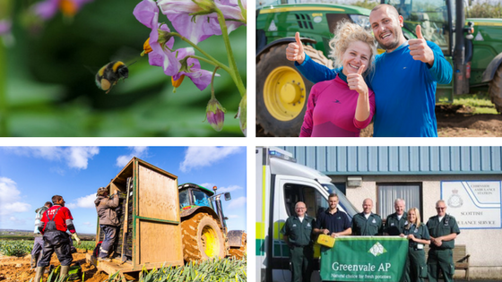

Our CSR strategy sets out to communicate our defined aims and approach; in addition our policy is continuously monitored and reviewed to remain current and effective.

# Our Environment

We take great pride and responsibility in the way we mitigate our environmental impact.

**The fresh produce sector relies heavily on natural resources and as one of the largest companies in this sector we do not take this for granted.**

## Greenvale AP

Over our 40 years of trading we have always been environmentally proactive and innovative. This is currently represented by our ISO14001 certified Group Environmental Policy and Management System, coupled with our group companies own environmental strategies. 2015 saw the launch of Green20, Greenvale AP’s group wide environmental plan. By focusing on water, carbon and waste we are committed to reducing their environmental impact. Green 20 aims to continue Greenvale’s environmental success, striving to achieve the following targets.

|  |  |  |
| --- | --- | --- |
| Group Target Area | 2014 Levels | Group Target by 2020 |
| Water (m3) | **151,028** | **35% reduction** |
| Carbon (kgCO2/Ton) | **34.65** | **30% reduction** |
| Waste | **90% diverted from landfill** | **All sites 0% to Landfill** |
| Renewable electricity | **1,000 MWh** | **35% of group electricity** |

Greenvale’s ‘Field to Fork’ view on the way they do business means that they tackle environmental issues from their grower base right through to the production and distribution process.

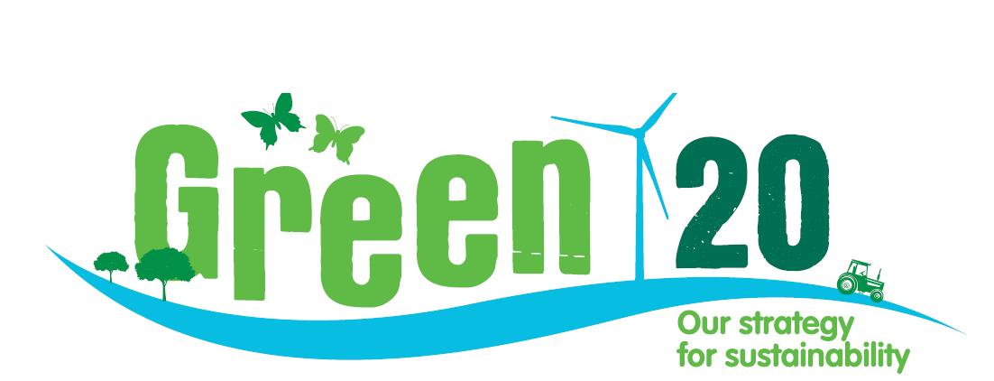

## Greenvale AP operational sites:

In line with their Green20 strategy Greenvale have implemented the following:

**Awards received for Cascade:**

* **Innovation of the year (Refresh awards, May 2010).**
* **Environmental Initiative (Sainsbury’s own label awards, June 2010).**
* **Green Apple Award (Gold – Food Section, House of Commons, November 2010).**
* **Sustainable use of natural resources (Footprint Forum Awards, June 2011).**
* Introduction of the award winning and innovative, chilled water recycling system Cascade to their packing sites; this system delivers 75% water saving in a high water consumption industry.
* Solar panels have been installed at their Cambridgeshire and Scottish sites over the last 3 years.
* 2014 saw the assembly of the 1.5MWH wind turbine at their Cambridgeshire site, leading to an average renewable energy supply at Floods Ferry of 75%.
* LED lighting has been rolled out as standard across all sites, which can amass a 65% energy saving.
* Secondary grade potatoes are processed through our potato processing company Swancote Foods to reduce waste streams.
* 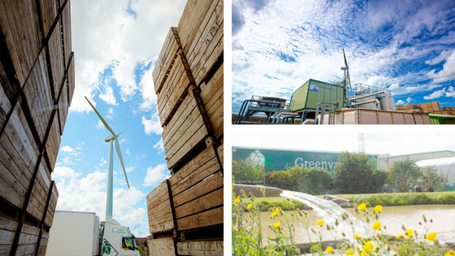Greenvale complied with the Energy Saving Opportunities Scheme (ESOS) in 2015, highlighting energy savings of around 30%.

**The Jersey Royal Company Ltd**

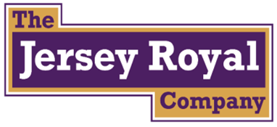The Jersey Royal Company is committed to farming in a sustainable manner that has a minimum impact on both the local and global environment.

All produce grown and marketed by The Jersey Royal Company adheres to strict criteria outlined in its own environmental management policy which is based on the ISO14001 standard.

The aim is to grow in a sustainable manner, and the company has a number of initiatives that minimise environmental impacts including:

* Continual reduction of inputs year on year
* Reduce, Re-use and Recycle' approach to waste
* Energy efficiency
* Wildlife and landscape conservation and enhancement

**Swancote Foods**

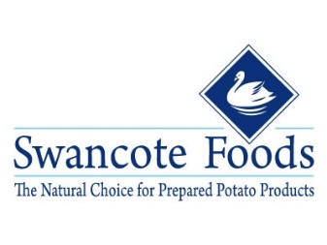Swancote now process all of their waste-streams through their feed plant, which produces a high energy, high dry matter animal feed.

This investment now means that they have enhanced their credentials for sustainability; and with much of our raw material sourced from Greenvale prepack outgrades, we can finally claim Zero Potato Waste.

## Our Growers

Across all of our group companies, including Greenvale AP, Rowe Farming Ltd and the Jersey Royal Company, our growers are environmentally aware, producing natural, healthy potatoes with nature in mind.

To achieve this we adopt the following measures:

* Greenvale Growing hubs are certified to ISO14001 for their Environmental Management.
* Growers employ Zynx, SOYL and trickle irrigation farming systems.
* We encourage our growers to undertake annual bird and insect counts, as well as incorporating wild flower field margins.
* We are continuously looking at ways to reduce the levels of pesticide residue detected in our products.
* All our packing sites are thoroughly tested each month for pesticide residue.
* Each of our growers signs an annual pesticide declaration.
* All our residue data is shared with the Chemicals Regulation Directive.
* Greenvale Seed is developing new varieties that require fewer inputs (Pesticide, Nitrogen and Water). Successful varieties to date include Vales Sovereign and Lady Balfour.
* Our growers are encourage to use equipment from our group company Restrain, Established in 2003, RestrainTM uses natural Ethylene gas to control sprouting on potatoes, a more environmentally friendly way to preserve crop than traditional methods.
* Also DeCyst, The only scientifically proven “trap crop” control method for Potato Cyst Nematode (PCN). DeCystTM is completely natural and safe to the environment.

# Responsible Sourcing and Ethical Trading

At Produce Investments, we want to source local British produce and trade with the highest integrity and ethical standards.

**We have ethical standards which underpin the behaviours of everyone engaged by Produce Investments and our group companies.**

We aim to create a culture of responsibility and fairness throughout our supply chain. This facilitates our commitment to ensuring everyone involved in producing our products work in conditions that meet or exceed the Ethical Trading Initiative Base Code and the International Labour Organisation Conventions.

## Ethical Policy

Our Ethical Policy represents our dedication to doing business in the correct manner, improving our good reputation and developing strong business relationships.

To ensure all our products come from responsible, ethical sources we adopt the following procedures:

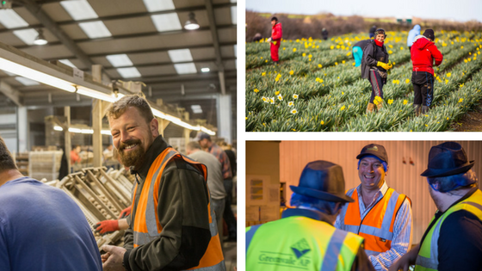

* “AB” and “B” Membership of Supplier Ethical Data Exchange (SEDEX).
* As an AB member Greenvale AP require our entire supplier base to join SEDEX and complete a self-assessment.
* All of our own production sites post their self-assessment information on the SEDEX website and update every 6 months.
* All of our production sites undergo independent third party ethical audits every 3 years which are posted onto the SEDEX website.
* All our overseas suppliers are required to post their information on SEDEX.
* We utilise the SEDEX risk assessment tool to pinpoint and address areas of concern within our supply base.
* We only use labour agencies that are approved by the Gangmaster Labour Abuse Authority (GLAA) and we also audit our labour suppliers.
* At Rowe Farming Ltd all staff are seasonal staff are employed on a direct basis, their seasonal returnee rate can be well over 80%.

## Supporting British Farmers and Local Produce

We are committed to sourcing British produce.

**This enables us to honour our commitments to British farmers and sourcing local produce, as well as the opportunity to improve present and future relationships.**

* We believe the quality and taste of British potatoes cannot be beaten.
* We are proud that over 95% of the potatoes we procure annually are grown in the UK.
* This supports local farmers, local economies and is better for the environment, reducing both our carbon footprint and food miles.
* Only when the British equivalent is not available do we commit to imported potatoes.
* We are ideally structured to ensure we provide the best UK potatoes.
* We have a strong network of buying, marketing and technical teams located in Cornwall, Herefordshire, East Anglia and Scotland.

## Working in partnership with our growers

We believe that solid, longstanding relationships with our grower base are a fundamental element in our success.

* We encourage an open and honest approach to business, where we understand and respect our growers operations, requirements and aspirations.
* This allows us to offer fair and attractive terms and conditions, whilst still providing the best value for our customers and consumers.
* We recognise the significance of supporting the agronomic skills development of our growers.
* 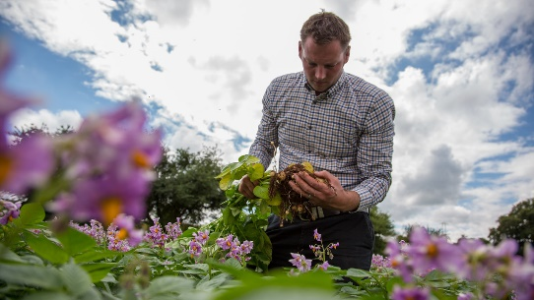This ensures their crops meet and exceed customer and consumer expectations, whilst still operating in an efficient and sustainable manner.
* Our relationships with our growers must be mutually beneficially therefore it is crucial we help each other as and when we can.
* We provide grower meetings, quality control training days and variety days all in aid of furthering our relationships, products and services.

# Our People

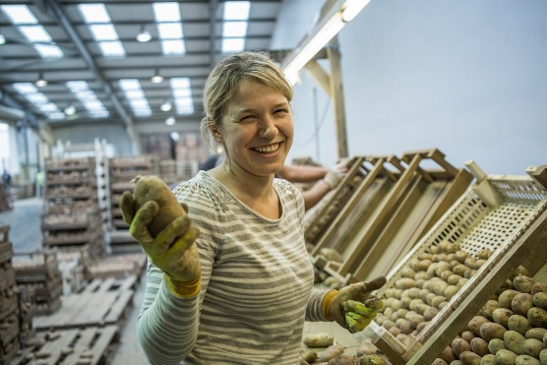The employees of Produce Investments and our group companies are as important to us as ever. We recognise and value the contribution of everyone who is involved with ensuring we keep producing a high quality product and service.

We are committed to improving and developing all members of our team, as well as creating an engaging workplace culture that is fair, safe and recognises hard work and success.

## Health & Safety

Our aim is not simply to comply with Health & Safety legislation, but to attain higher standards through the adoption of good practice and to achieve industry leadership in our Health and Safety performance – as evidenced by our OHSAS 18001 occupational health and safety management accreditation.

**In line with our values, we see health and safety as a fundamental part of our operations.**

We are committed to achieving a safe and healthy working environment for all people that are affected by our work activities, and promote the company as a responsible employer.

* The Board of Directors is fully committed to achieving this through a programme of continuous improvement, monitoring, review and positively promoting a proactive approach.
* We believe that effective health and safety practices contribute directly to the better performance of the company as a whole.
* All levels of management and operations have a duty to employ safe systems of work.
* All Produce Investments company people hold the ultimate responsibility for the safety and welfare of themselves and others, through implementation of our Group companies Health and Safety policies and behavioural safety standards.
* In order to further improve our Health and Safety performance, the company has embarked on a behavioural safety programme.

## Learning and Development

We invest heavily in both the personal and professional development of our people; this facilitates continued excellence in what we do.

Within our group companies we aim to bring individuals together with the sharing of knowledge, skills and experiences, whilst focusing on key areas of business and developmental needs.

**Produce Investments’ Management Development Programme:**

* **A selection of employees spend 6 months developing and improving their business skills in readiness for their next move - or simply to further improve their existing performance.**
* **The programme includes 360 degree feedback, 1:1 coaching, on the job coaching and off site training courses.**
* **To date, approximately 50 of our current employees have been through this process, including a number of our senior managers.**

**Produce Investments’ Graduate Development Programme:**

* **We employ a number of high calibre graduates each year.**
* **Each graduate spends two years working in different areas of the business before taking up a permanent position.**
* **Graduates are mentored through the programme, having regular reviews and attending development programmes focussing on key business skills.**

**Our Mentoring Programme:**

* **Aimed specifically at the development of our Operations team.**
* **Our middle managers have a designated mentor to assist in their overall development.**

**Greenvale’s Modern Apprenticeship Programme:**

* **Aimed at recruiting and developing young talent.**
* **Delivers a National Vocational Qualification at Level 2.**
* **Working in partnership with the University of Lincoln and the Scottish Qualifications Authority (SQA)**

**Our comprehensive appraisal process:**

* **Sets and reviews an individual’s business objectives.**
* **Develops individual’s competence to carry out their role.**
* **Via the appraisal process we also review our company vision, values and where individuals can contribute**.

## Engagement

**We are committed to recognising and valuing our employee’s efforts and practise an open dialogue to ensure effective communication is always utilised.**

We continuously aim to exceed the expectations of our employees, as we believe a happy and motivated workforce is an efficient and productive one.

Examples of employee engagement within the group:

* Group and Site Communication Teams that meet quarterly, representing all functions, to discuss what is happening within the company.

**We employ up to 2,200 people throughout the UK.**

* Company intranet to facilitate speedy and comprehensive communication.
* The Produce Times – our own company newspaper.
* Our external whistle-blowing service, Safecall, which allows employees to confidentially and anonymously report any issues they come across at work.
* Our Director Road Show where the Chief Executive and other Directors tour our sites holding open forum Q&A sessions for staff.
* At The Jersey Royal Company Ltd staff representation is achieved by means of a Staff Liaison Committee. The committee meets 4 times per year and allows an exchange of information and views between staff and management. The prime focus of this committee is raising awareness of health and safety matters, however any work related matters can be discussed at these meetings.
* Employee Engagement Survey - “Your Voice”

## Benefits

In line with our core values Produce Investments offers a range of benefits to its employees in order to remain competitive and to encourage loyalty, this is in recognition and reward for the continued hard work of everyone involved.

Depending on your position within our companies benefits can include:

**Loyal service award scheme**

**Premium rate overtime**

**Pension scheme**

**Company sick pay scheme**

**Childcare vouchers**

**Life assurance**

**Income protection**

# Produce Investments in the local community

We recognise the difference we can make within our local communities by providing jobs, services and supporting various charities and causes. We rely on local communities supporting us and we believe it has to be a mutually favourable relationship.

Our group companies may initiate and support community investment and educational programs.  We aim to support local charities and education as well as continuing to employ from the communities around our sites across the U.K.

## Supporting Education and the Local Community

As a group with companies within several local communities we believe it a responsibility, as well as a privilege, to support local schools and children.

* **Grow Your Own Potato campaign:**

Each year, in conjunction with the Potato Council Ltd, Greenvale AP participates in the Grow Your Own Potato campaign. This particular scheme helps to educate school children on how to grow potatoes and the benefits of a healthy diet.



* **Tattie Tales:**

Similarly, Greenvale Seed supports a project known as ‘Tattie Tales’ organised by the Royal Highland Educational Trust. The project encourages school children to grow and harvest their own crop with prizes available.

* **Children’s Countryside Day:**

We also support educational events such as the Children’s Countryside Day run by the Borders Union Agricultural Society. School children aged between 5 and 9 engage with local companies to learn about various rural issues, the life cycle of the potato and the importance of healthy eating.

* 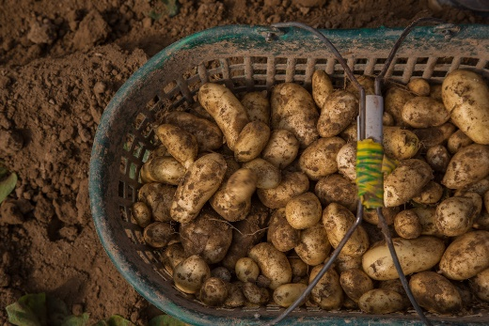**Jersey Royal Potato Growing Competition:**

The competition which is sponsored by The Channel Islands Co-operative Society, sees children and other Islanders compete to grow the heaviest crop of Jersey Royals … and to achieve the highest yield. Each competitor receives a growing kit comprising two Jersey Royal seed potatoes, polystyrene chips, compost and fertiliser – and a bucket to grow them in. All the competitors will be judged at a weigh-off event to be held at the end of May.

## Supporting Charities

Each year we allocate money to our sites across the UK and allow employees to decide which causes they want to donate the money to. We encourage staff to nominate charities that they believe to be deserving of it.

2017 will be no different with money being distributed within the group for donations. Furthermore our group companies are set a charity challenge of holding additional events to raise money for their chosen charities.

Below are examples of Charities and causes we work with each year:

**GroceryAid**

* 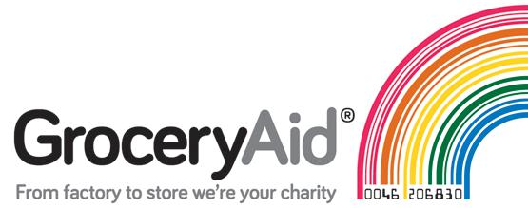Established in 1857, the charity has been a very successfully run welfare fund, supported by the leading companies in the food and drink industry.
* They provide regular monetary support, crisis grants, respite care and other services to those with the Food and Drink industry who are in need.
* GroceryAid offers professional advisers and a wide range of online services. Focusing on personal problems, financial guidance, legal support, workload, health and wellbeing and depression.
* We provide monetary donations through charity events and challenges across our group companies.

**Fenland Area Community Enterprise Trust (FACET)**

* FACET provide Skills for Work and Independent Living Skills training for adults with learning and other disabilities including physical or sensory impairment, mental health problems or who are head injury victims.
* The training is designed to help the students to achieve their full potential in life through a range of activities including horticulture, sport, music, arts and crafts and woodwork.
* Greenvale provide monetary donations as well as seed potato for the students to grow their own.



**FareShare**

* Through this partnership Greenvale AP put spare potatoes to good use.
* Any misshapen, overspill or incorrectly sized potatoes, that otherwise would be put to waste, are being donated to FareShare, where it can be redistributed to one of the 900 charities they support.
* This affiliation helps to reduce our waste stream, but most importantly helps to feed the homeless, families in need and other vulnerable people.

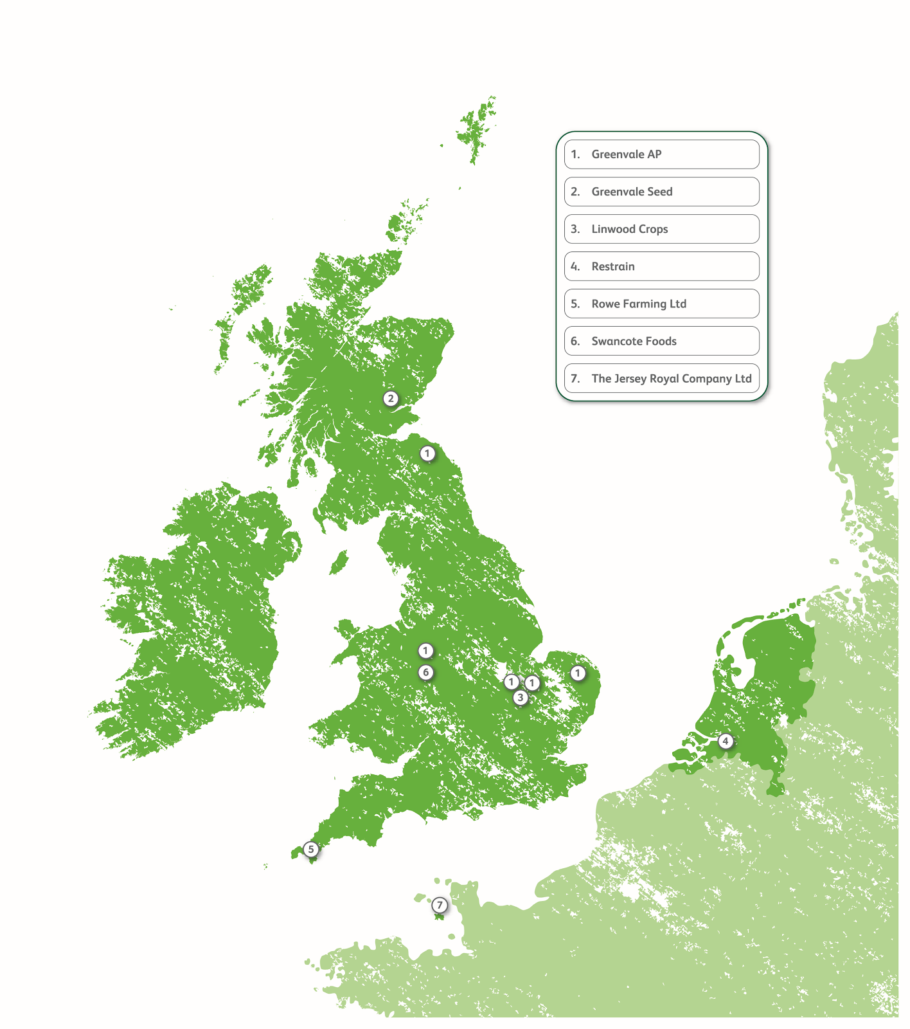

For any further information regarding our CSR policy please visit our website [www.produceinvestments.co.uk](http://www.produceinvestments.co.uk)